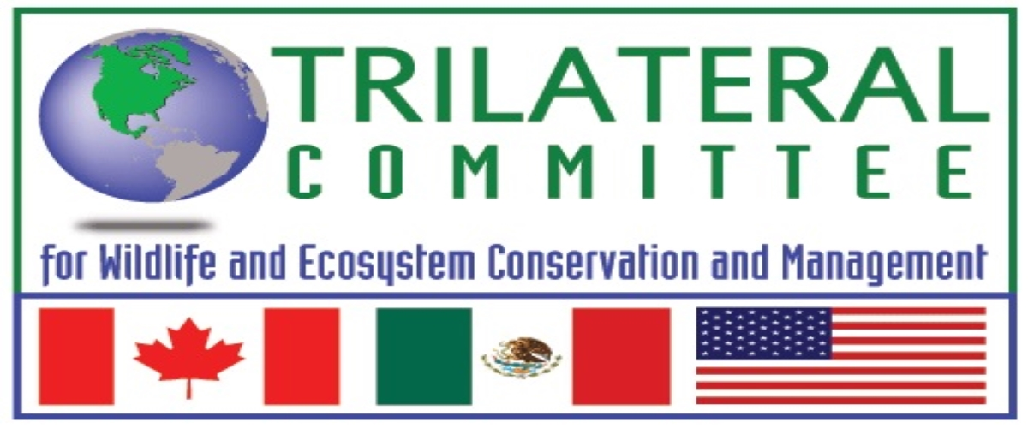

XXVII Annual Meeting of The Canada/Mexico/United States Trilateral Committee for Wildlife and Ecosystem Conservation and Management

June 27-30, 2023, Virtual Meeting
Hosted by Dirección General de Vida Silvestre - SEMARNAT - Mexico

Meeting Registration Form
*************************************************************************************
First Name & Initial | Last Name
Business Title | Agency/Organization
Postal Address

City | Province/State
Postal/Zip Code | Country
Business Phone | Mobile
E-mail

Working Table(s) you will be attending:  Opening ceremony ____  Ecosystem Conservation ____  Executive ____  Law Enforcement* ____  Migratory Birds ____  Species of Common Concern ____  Closing Ceremony ____  (*closed session) | Please indicate if you are a:  Participant ____  Guest ____
Indicate the specific topic in which you will participate:

Once the form is completed, scan it in pdf format and send it to the
following email: trilateral.dgvs@semarnat.gob.mx by june 9, 2023.

